# 

Figure

# cbse-central-board-of-secondary-education-logo-FF37539DA3-seeklogo.com.pngdownload.jpgCertificate

This is to certify that **AMAN UPADHYAY** of

Std. Xll ’B’ has completed the computer Project on **‘SCHOOL MANAGEMENT SYSTEM’** under the guidance of his compute teacher **Mr. Maninder Singh.**

**---------------------------------------- -----------------------------------------**

**Signature of Internal Examiner Signature of External Examiner**

**------------------------------**

**Signature of Principal**

**Table of contents**

|  |  |  |
| --- | --- | --- |
| **S.no** | **CONTENTS** | **PAGE NO.** |
| 1. | ACKNOWLEDGEMENT | 4 |
| 2. | INTRODUCTION | 5 |
| 3. | HARDWARE AND SOFTWARE REQUIREMENTS | 6 |
| 4. | SOURCE CODE | 7-26 |
| 5. | RUN SCREENSHOTS | 27-31 |
| 6. |  |  |
| 7. |  |  |

**Acknowledgment**

“Gratitude is the fairest blossom which springs from the soul”

Feeling gratitude and not expressing it is like wrapping a present and not giving it. We take this opportunity to convey our heartfelt gratitude to each and every one who has supported us in every way or the other during the course of our project.

I would like to express my humble gratitude towards our Principal Ma’am Mrs. Mili Sinha for giving us such an opportunity to enhance our skills.

From the very core of our heart, we would like to express our sincere gratitude to Mr. Gurpreet Sir & Maninder Sir for his supervisory guidance. We are always indebted to him for his kind support and constant encouragement and his enthusiasm to complete our project milestones.

It requires lots of efforts in terms of cooperation and support to fulfill various tasks involved during the project. We are always grateful to our peers and friends who have always encouraged us and guided us whenever we needed assistance.

We also take this opportunity to express our appreciation to all the participants involved during our preliminary research for their invaluable time to answer our queries and suggestions for the application to be developed.

Things always remain hidden in the shadow of the unsung heroes; still we would to thank all the people passively involved in the assignment, people who encouraged us day in and day out to make it a success.

At last but above all, we thank the Almighty for his blessings.

**INTRODUCTION**

SCHOOL MANAGEMENT project in PYTHON is a simple console application built without the use of graphics. This project School Management help in managing the student data and the fee data. In this project we tried to enter all details of students and tried to maintain all the possibility which may help the user to enter more record if he/she requires.

This is a multipurpose program which can be used to administer the student’s data and their fee data simultaneously.The program can also be used to serve for data handling and keeping their records.The program saves the student data and their fee data in their respective files.The program is also flexible and the user can change or add any feature according to their demand.

**1. Create record**: This feature creates a new student records. For thistheinformation to be provided are the admission number , name, age , father’s name , mother’s name **.**

**2.View records**: This program also helps in reviewing the student’s data and their fee record.

**3. Modify records:** It also serves for modification of the student’s data and the fee calculation

**HARDWARE AND SOFTWARE REQUIREMENTS**

* **SOFTWARE REQUIREMENTS**
* Processors: Intel Atom® processor or Intel® Core™ i3 processor
* Disk space: 1 GB
* Operating systems: Windows* 7 or later, macOS, and Linux
* Python* versions: 2.7.X, 3.6.X, 3.7X, 3.8X .
* **HARDWARE REQUIREMENTS**
* Keyboard
* Mouse
* Monitor

SOURCE CODE

"""****************************************************************************

MODULES USED IN PROJECT

*****************************************************************************"""

import pickle

import os

"""*****************************************************************************

studata CLASS USED IN PROJECT

*****************************************************************************"""

class studata(object):

def __init__(s):

s.admno=0

s.roll=0

s.name=""

s.fname=""

s.mname=""

s.dob=""

s.sclass=0

s.sec=""

def create_studata(s): #function to get data from user

s.admno=int(input("\nEnter admission number: "))

name=input("\n\nEnter the name of the student: ")

s.name=name.upper()

mname=input("\nName of Mother: ")

s.mname=mname.upper()

fname=input("\nName of Father: ")

s.fname=fname.upper()

s.dob=input("\nEnter date of birth: ")

def show_studata(s): #function to show data on screen

print( "\nAdmission No.: ", s.admno)

print( "\nStudent name: ", s.name)

print( "\nMother's Name: ", s.mname)

print( "\nFather's Name: ", s.fname)

print( "\nDate of Birth: ", s.dob)

def modify(s): #function to get new data from user

print( "\nAdmission No.: ", s.admno)

name=input("\n\nEnter the name of the student: ")

s.name=name.upper()

mname=input("\nName of Mother: ")

s.mname=mname.upper()

fname=input("\nName of Father: ")

s.fname=fname.upper()

dob=input("\nEnter date of birth: ")

def report(s): #function to show data in tabular format

print( "%-15s"%s.admno,"%-20s"%s.name.strip(),"%-20s"%s.mname,"%-20s"%s.fname,"%-20s"%s.dob)

def retadmno(s): #function to return account number

return s.admno

def retfname(s): #function to return balance amount

return s.fname

def retmname(s): #function to return type of account

return s.mname

"""*****************************************************************************

feedata CLASS USED IN PROJECT

*****************************************************************************"""

class feedata(object):

def __init__(s):

s.trno=0

s.admno=0

s.name=""

s.fmonth=""

s.famt=0

s.date=""

def getFeeData(s):

flag=0

try:

inFile=open("student.dat","rb")

n=int(input("Enter the Admission number: "))

while True:

stu=pickle.load(inFile)

if stu.retadmno()==n:

s.trno=int(input("\nEnter Transaction number: "))

s.admno=n

s.name=stu.name

fm=input("\nEnter the fee quarter: ")

s.fmonth=fm.upper()

s.famt=int(input("\nEnter the fee of the student: "))

s.date=input("\nEnter the fee date: ")

flag=1

except EOFError:

inFile.close()

if flag==0:

print( "\n Admission number not exist ")

return flag

except IOError:

print( " studata.dat : File could not be open !! Press any Key...")

return flag

def show_feedata(s):

print("\nTransaction number: ",s.trno)

print("\nAdmission No.: ", s.admno)

print("\nStudent name: ", s.name)

print("\nFee Quarter: ",s.fmonth)

print("\nFee Amount: ",s.famt)

print("\nFee Date: ",s.date)

def modify(s):

print("\nTransaction number: ",s.trno)

s.admno=int(input("\nEnter admission number: "))

name=input("\nEnter the name of the student: ")

s.name=name.upper()

fm=input("\nEnter the fee quarter: ")

s.fmonth=fm.upper()

s.famt=int(input("\nEnter the fee of the student: "))

s.date=input("\nEnter the fee date: ")

def report(s): #function to show data in tabular format

print( "%-10s"%s.trno,"%-20s"%s.name,"%-10s"%s.fmonth,"%-6s"%s.famt)

def rettrno(s):

return s.trno

def retadmno(s):

return s.admno

def retname(s):

return s.name

def retfmonth(s):

return s.fmonth

def retfamt(s):

return s.famt

def retdate(s):

return s.date

#*****************************************************************************

# FUNCTION TO WRITE RECORD IN BINARY FILE

#*****************************************************************************

def write_studata():

try:

st=studata()

outFile=open("student.dat","ab")

st.create_studata()

pickle.dump(st,outFile)

outFile.close()

print( "\n\n Student details added Successfully")

print( "\n\n YOUR ADMISSION NUMBER IS: ",st.retadmno())

except:

pass

def write_feedata():

try:

fe=feedata()

outFile=open("feedata.dat","ab")

flag=fe.getFeeData()

if flag==1:

pickle.dump(fe,outFile)

print( "\n\n FEEDATA CREATED SUCCESSFULLY")

print( "\n\n YOUR TRANSACTION NUMBER IS: ",fe.rettrno())

outFile.close()

except:

pass

"""*****************************************************************************

FUNCTION TO DISPLAY STUDENT DETAILS GIVEN BY USER

*****************************************************************************"""

def display_studata(n):

flag=0

try:

inFile=open("student.dat","rb")

print( "\nSTUDENT DETAILS\n")

while True:

st=pickle.load(inFile)

if st.retadmno()==n:

st.show_studata()

flag=1

except EOFError:

inFile.close()

if flag==0:

print( "\n\n student data not exist ")

except IOError:

print( "File could not be open !! Press any Key...")

"""*****************************************************************************

FUNCTION TO DISPLAY FEE DETAILS GIVEN BY USER

*****************************************************************************"""

def display_feedata(n):

flag=0

try:

inFile=open("feedata.dat","rb")

print( "\nFEE DETAILS\n")

while True:

fe=pickle.load(inFile)

if fe.rettrno()==n:

fe.show_feedata()

flag=1

except EOFError:

inFile.close

if flag==0:

print( "\n\nTHIS TRANSACTION NUMBER DOES NOT EXIST")

except IOError:

print( "File could not be open !! Press any Key...")

"""*****************************************************************************

FUNCTION TO MODIFY STUDENT RECORD OF FILE

*****************************************************************************"""

def modify_studata(n):

found=0

try:

inFile=open("student.dat","rb")

outFile=open("temp.dat","wb")

while True:

st=pickle.load(inFile)

if st.retadmno()==n:

print( 30*"-")

st.show_studata()

print( 30*"-")

print( "\n\nEnter The New Details of Account")

st.modify()

pickle.dump(st,outFile)

print( "\n\n\tRecord Updated")

found=1

else:

pickle.dump(st,outFile)

except EOFError:

inFile.close()

outFile.close()

if found==0:

print( "\n\nRecord Not Found ")

except IOError:

print( "File could not be open !! Press any Key...")

os.remove("student.dat")

os.rename("temp.dat","student.dat")

"""*****************************************************************************

FUNCTION TO MODIFY FEE RECORD OF FILE

*****************************************************************************"""

def modify_feedata(n):

found=0

try:

inFile=open("feedata.dat","rb")

outFile=open("temp.dat","ab")

while True:

fe=pickle.load(inFile)

if fe.rettrno()==n:

print( 30*"-")

fe.show_feedata()

print( 30*"-")

print( "\n\nENTER THE NEW DETAILS OF THE STUDENT")

fe.modify()

pickle.dump(fe,outFile)

print( "\n\n\tRECORD UPDATED")

found=1

else:

pickle.dump(fe,outFile)

except EOFError:

inFile.close()

outFile.close()

if found==0:

print( "\n\nRECORD NOT FOUND ")

except IOError:

print( "File could not be open !! Press any Key...")

os.remove("feedata.dat")

os.rename("temp.dat","feedata.dat")

"""*****************************************************************************

FUNCTION TO DELETE STUDENT RECORD OF FILE

*****************************************************************************"""

def delete_studata(n):

found=0

try:

inFile=open("student.dat","rb")

outFile=open("temp.dat","wb")

while True:

st=pickle.load(inFile)

if st.retadmno()==n:

found=1

print( "\n\n\tRecord Deleted ..")

else:

pickle.dump(st,outFile)

except EOFError:

inFile.close()

outFile.close()

if found==0:

print( "\n\nRecord Not Found")

except IOError:

print( "File could not be open !! Press any Key...")

os.remove("student.dat")

os.rename("temp.dat","student.dat")

"""*****************************************************************************

FUNCTION TO DELETE FEE RECORD OF FILE

*****************************************************************************"""

def delete_feedata(n):

found=0

try:

inFile=open("feedata.dat","rb")

outFile=open("temp.dat","wb")

while True:

fe=pickle.load(inFile)

if fe.rettrno()==n:

found=1

print( "\n\n\tRECORD DELETED ..")

else:

pickle.dump(fe,outFile)

except EOFError:

inFile.close()

outFile.close()

if found==0:

print( "\n\nRECORD NOT FOUND")

except IOError:

print( "File could not be open !! Press any Key...")

os.remove("feedata.dat")

os.rename("temp.dat","feedata.dat")

"""*****************************************************************************

FUNCTION TO DISPLAY ALL ACCOUNT DETAILS

*****************************************************************************"""

def display_allStudent():

print( "\n\nSTUDENT DATA LIST\n\n")

print( 60*"=")

print( "%-10s"%"Adm No.","%-20s"%"Name","%-20s"%"Mother's name","%-20s"%"Father's name" ,"%-20s"%"Date of birth")

print( 60*"=","\n")

try:

inFile=open("student.dat","rb")

while True:

st=pickle.load(inFile)

st.report()

except EOFError:

inFile.close()

except IOError:

print( "File could not be open !! Press any Key...")

"""*****************************************************************************

FUNCTION TO DISPLAY ALL FEE DETAILS

*****************************************************************************"""

def display_allFee():

print( "\n\n\tSTUDENT FEEDATA LIST\n\n")

print( 60*"=")

print( "%-10s"%"TR.NO.","%-20s"%"NAME","%-10s"%"MONTH","%-6s"%"AMOUNT")

print( 60*"=","\n")

try:

inFile=open("feedata.dat","rb")

while True:

fe=pickle.load(inFile)

fe.report()

except EOFError:

inFile.close()

except IOError:

print( "File could not be open !! Press any Key...")

"""*****************************************************************************

INTRODUCTORY FUNCTION

*****************************************************************************"""

def intro():

print( "\n\n\t\t SCHOOL MANAGEMENT SYSTEM")

print( "\n \t\tJUSCO SCHOOL SOUTH PARK, BISTUPUR")

print( "\n\n\nMADE BY: SHASHI KUMAR SINGH AND AMAN UPHADYAY")

print( "\nSCHOOL : JUSCO SCHOOL SOUTH PARK")

"""*****************************************************************************

THE FEE MENU FUNCTION OF PROGRAM

*****************************************************************************"""

def FeeMenu():

while True:

print( 3*"\n",70*"=")

print( "FEE MENU:")

print( 3*"\n",70*"=")

print( "1. ADD NEW FEE DETAILS")

print( "2. SHOW FEE DETAILS")

print( "3. SHOW FEE DETAILS OF ALL STUDENT")

print( "4. DELETE FEE DETAILS")

print( "5. MODIFY FEE DETAILS")

print( "6. EXIT")

try:

ch=int(input("ENTER YOUR CHOICE(1~8): "))

if ch==1:

write_feedata()

elif ch==2:

num=int(input("\n\nENTER TRANSACTION NUMBER: "))

display_feedata(num)

elif ch==3:

display_allFee()

elif ch==4:

num=int(input("\n\nENTER TRANSACTION NUMBER: "))

delete_feedata(num)

elif ch==5:

num=int(input("\n\nENTER TRANSACTION NUMBER: "))

modify_feedata(num)

elif ch==6:

break

else:

print( "INPUT CORRECT CHOICE...(1~6)")

except NameError:

print( "INPUT CORRECT CHOICE...(1~6)")

"""*****************************************************************************

THE STUDENT MENU FUNCTION OF PROGRAM

*****************************************************************************"""

def StudentMenu():

while True:

print( 3*"\n",70*"=")

print( "STUDENT MENU:")

print( "1. New Admission")

print( "2. Modify Student ")

print( "3. Delete Student")

print( "4. Student Enquiry")

print( "5. All Student List")

print( "6. Return to Main Menu")

try:

ch=int(input("Enter Your Choice(1~6): "))

if ch==1:

write_studata()

elif ch==2:

num=int(input("\n\nEnter Admission Number : "))

modify_studata(num)

elif ch==3:

num=int(input("\n\nEnter Admission Number : "))

delete_studata(num)

elif ch==4:

num=int(input("\n\nEnter Admission Number : "))

display_studata(num)

elif ch==5:

display_allStudent()

elif ch==6:

break

else:

print( "Input correcr choice...(1-6)")

except NameError:

print( "Input correct choice...(1-6)")

"""*****************************************************************************

THE STUDENT MENU FUNCTION OF PROGRAM

*****************************************************************************"""

intro()

while True:

print( 3*"\n",70*"=")

print( "MAIN MENU:")

print( "1. STUDENT MENU")

print( "2. FEE MENU ")

print( "3. Exit")

try:

ch=int(input("Enter Your Choice(1~3): "))

if ch==1:

StudentMenu()

elif ch==2:

FeeMenu()

elif ch==3:

break

else:

print( "Input correcr choice...(1-3)")

except NameError:

print( "Input correct choice...(1-3)")

input("\n\n\n\n\nTHANK YOU\n\nPress any key to exit...")

"""*****************************************************************************

END OF PROJECT

*****************************************************************************"""

RUN SCREENSHOTS

**WELCOME PAGE:**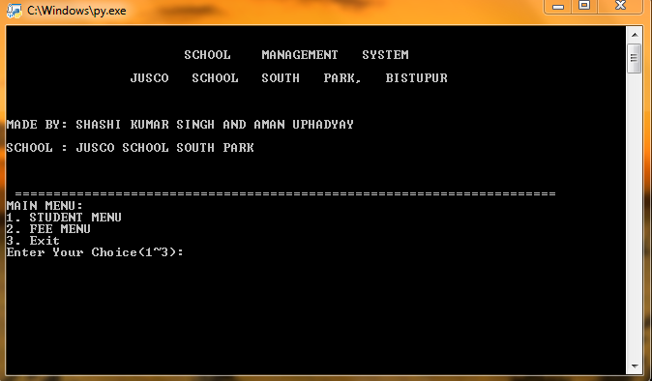

**STUDENT MENU:**

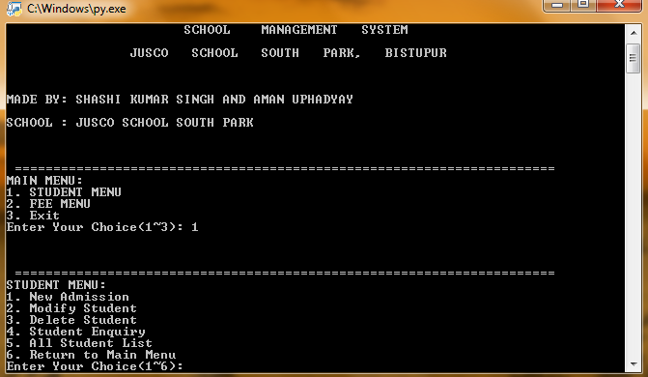

**ADDING STUDENT’S DETAILS:**

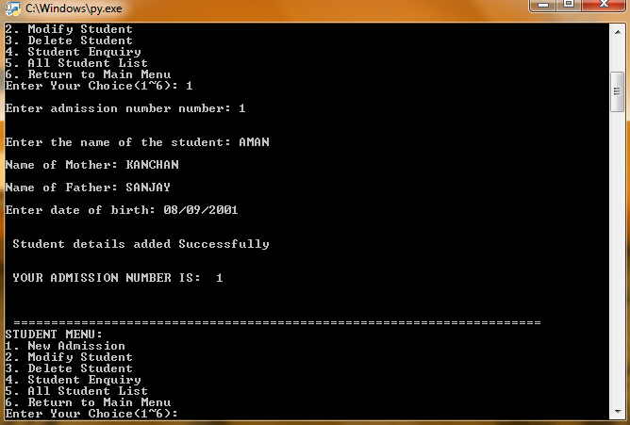

**MODIFYING STUDENT’S DETAILS:**

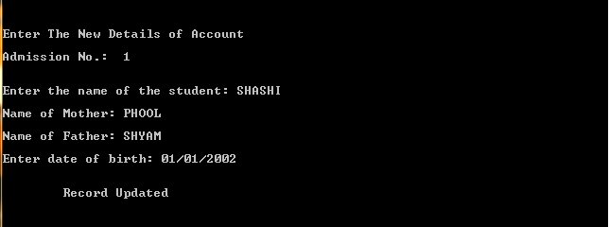

**VIEW FULL LIST OF ENROLLED STUDENTS:**

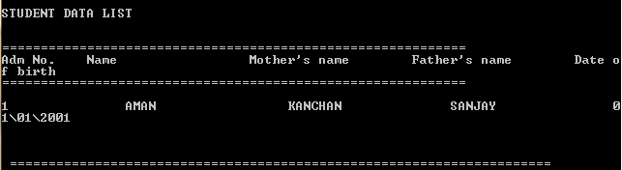

**DELETING STUDENT RECORD:**

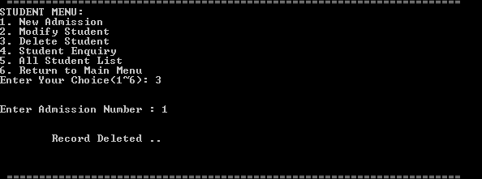

**STUDENT’S FEE MENU:**

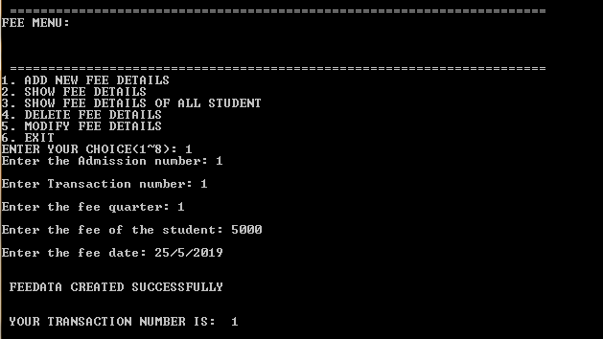

**VIEWING FULL LIST OF STUDENTS WHO HAVE PAID THE FEES:**

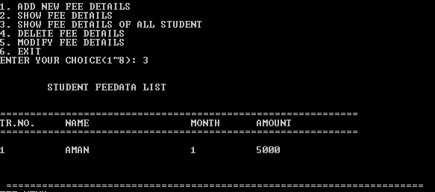

**MODIFYING STUDENT’S FEE DETAILS:**

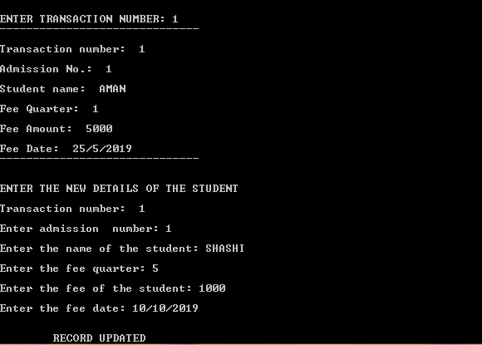

**DELETING FEE RECORD:**

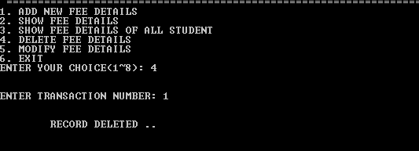

THANK YOU